**Réseaux/Networks**

**TP2**

Lab-View Network Device MAC Addresses ………………………………………… 2

Lab - View the Switch MAC Address Table ………………………………………… 8

Packet Tracer-Build a Switch and Router Network - Physical Mode …… 17

Packet Tracer - Examine the ARP Table ……………………………………………… 25

G1:

GUO Xiaofan

Zhao Chao

# Lab-View Network Device MAC Addresses

**Ex1/ Part 1/**Step 1/a.&b.:

**Ex1/ Part 1/**Step 2/a.

**Ex1/ Part 1/**Step 2/b.

**Were the pings successful? Explain**

No. The switch has not been configured now.

**Ex1/ Part 1/**Step 3/a.

**Ex1/ Part 1/**Step 3/b.&c.&d.

**Ex1/ Part 1/**Step 4

**Were the pings successful?**

Yes.

**Ex1/ Part 2/**Step 1/a.

**What is the OUI portion of the MAC address for this device?**

5C-26-0A

**What is the serial number portion of the MAC address for this device?**

24-2A-60

**Using the example above, find the name of the vendor that manufactured this NIC.**

Dell Inc.

**Ex1/ Part 2/**Step 1/b.

**Identify the serial number portion of the MAC address for the NIC of PC-A.**

75.71AE

**Identify the name of the vendor that manufactured the NIC of PC-A.**

0001.63

Cisco Systems, Inc

**Ex1/ Part 2/**Step 2/a.

**What is the MAC address for VLAN 1 on S1?**

000a.419d.7b04

**What is the MAC serial number for VLAN 1?**

9d.7b04

**What is the OUI for VLAN 1?**

00-0a-41

**Based on this OUI, what is the name of the vendor?**

Cisco Systems

**What does bia stand for?**

Burned in address.

**Why does the output show the same MAC address twice?**

The MAC address is alterable through a software command, yet the original address (bia) remains unchanged and is displayed within parentheses.

**Ex1/ Part 2/**Step 2/b.

**What Layer 2 addresses are displayed on S1?**

000A.419D.7B04

0001.6375.71AE

**What Layer 3 addresses are displayed on S1?**

192.168.1.2

192.168.1.3

**Ex1/ Part 2/**Step 3/ **Did the switch display the MAC address of PC-A? If you answered yes, what port was it on?**

Yes. Port should be F0/6. Answers will vary for the MAC address. In the example above, the MAC address would be 5c26.0a24.2a60.

**Ex1/ Part 2/** Reflection Questions/1.  **Can you have broadcasts at the Layer 2 level? If so, what would the MAC address be?**

Layer 2 allows for broadcasts.

ARP utilizes broadcasts to retrieve MAC address information.

The broadcast address is FF.FF.FF.FF.FF.FF.

**Ex1/ Part 2/** Reflection Questions/2. **Why would you need to know the MAC address of a device.**

Several reasons might exist. In expansive networks, identifying a device by its MAC address might prove simpler than using its IP address, aiding in location and identification. The MAC OUI reveals the manufacturer, aiding in narrowing down the search. Additionally, Layer 2 supports security measures, necessitating knowledge of permissible MAC addresses.

# Lab - View the Switch MAC Address Table

**Ex2/ Part 1/**Step 1:

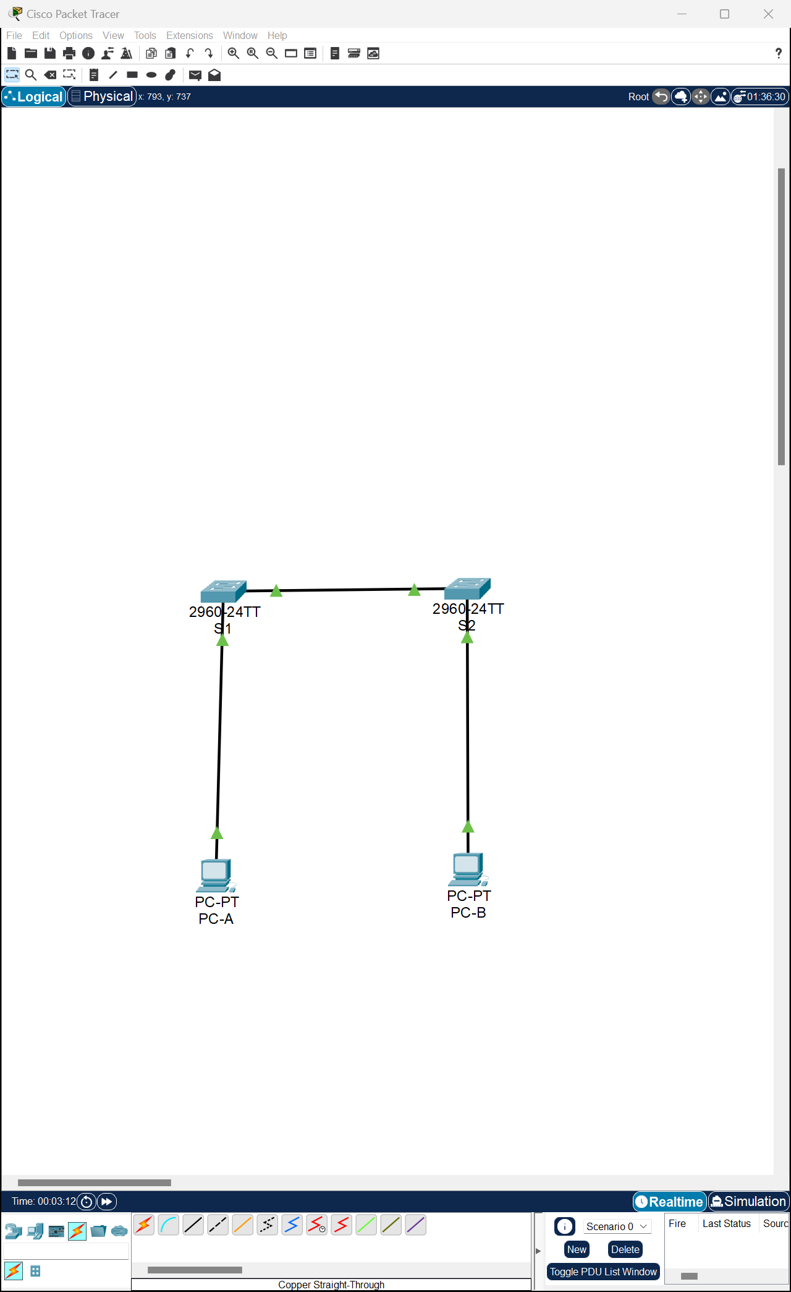

**Ex2/ Part 1/**Step 2:

**Ex2/ Part 1/**Step 3:

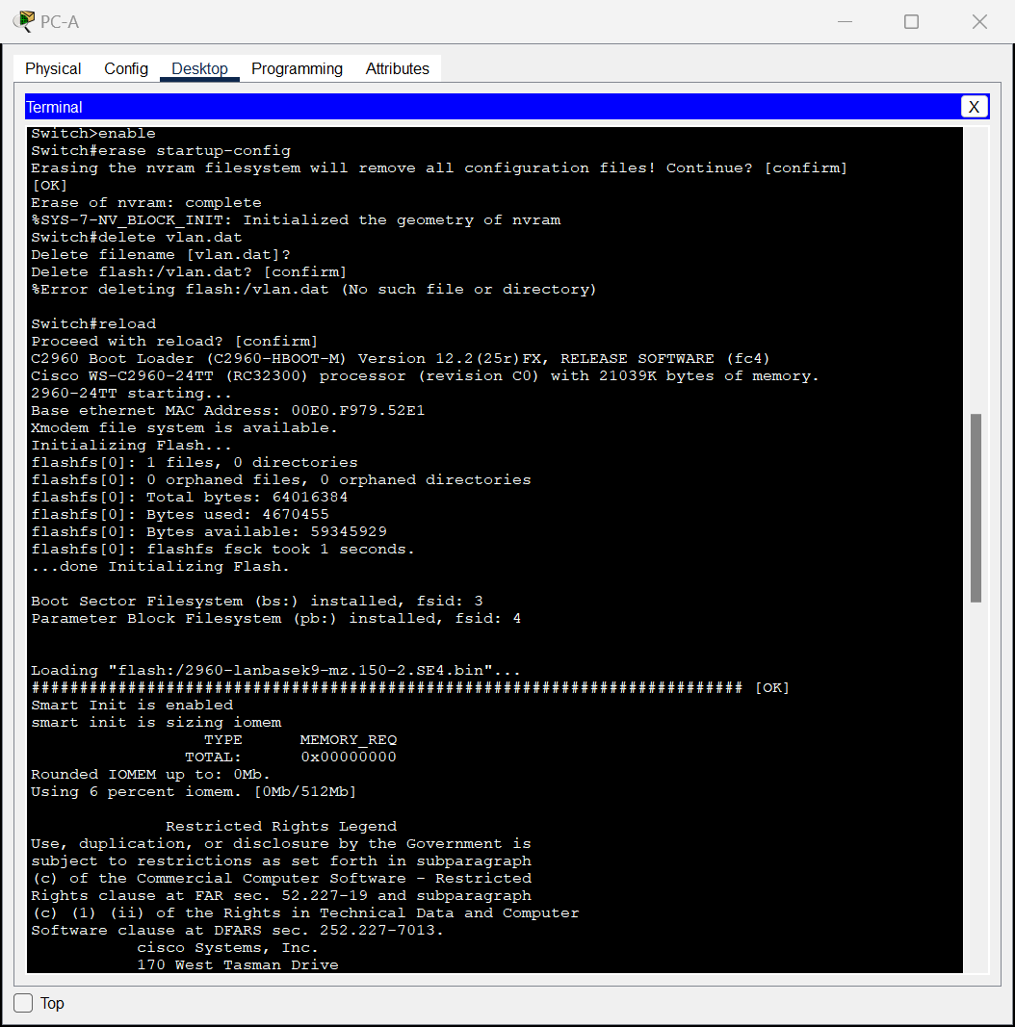

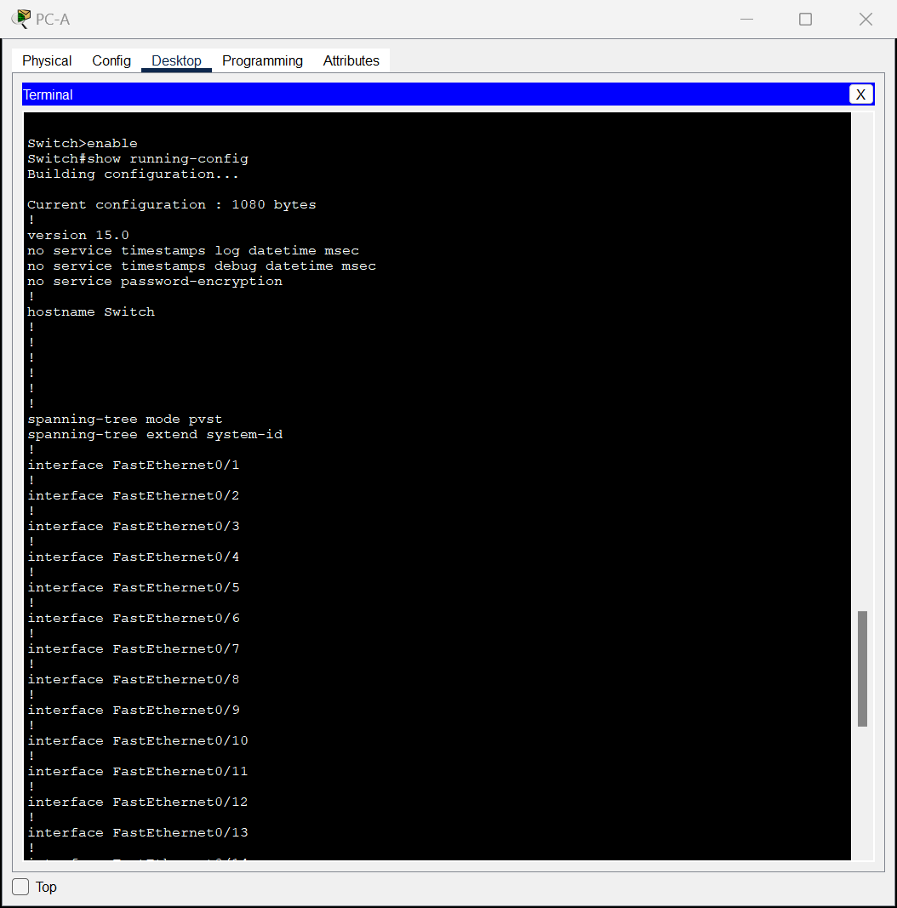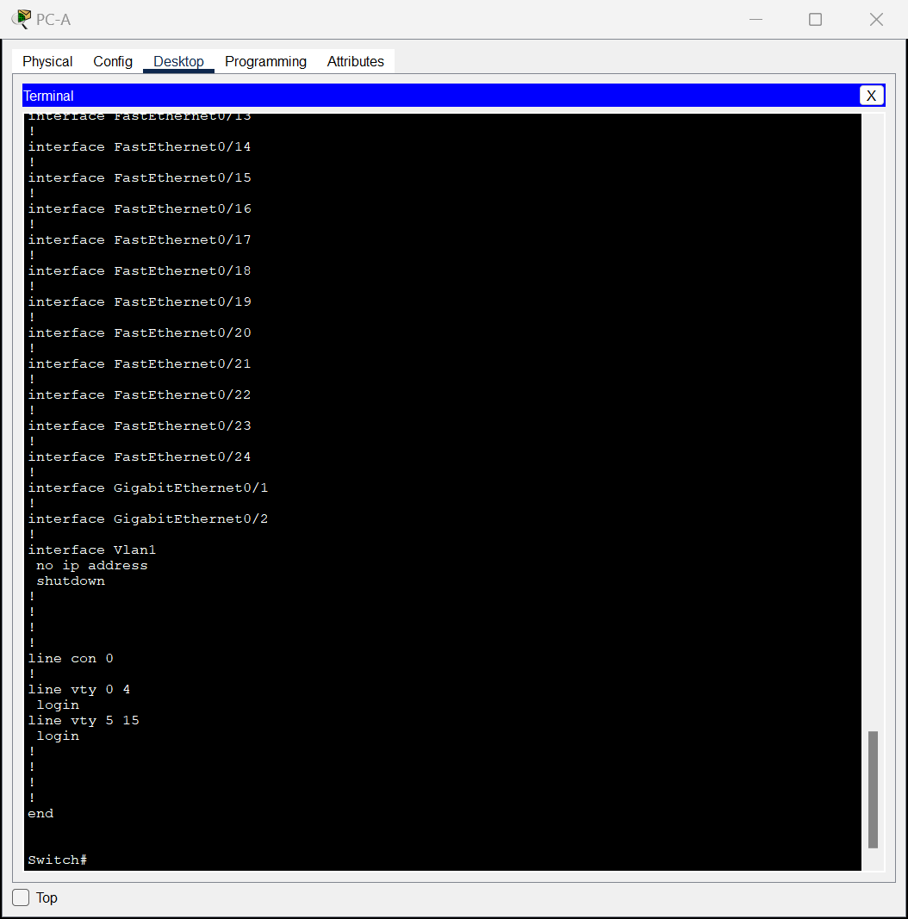

**图形用户界面

中度可信度描述已自动生成Ex2/ Part 1/**Step 4/a:

**Ex2/ Part 1/**Step 4/b.

**Ex2/ Part 1/**Step 4/c.

**Ex2/ Part 1/**Step 4/d.



**Ex2/ Part 2**/Step 1/a:

**PC-A MAC Address:** 00E0.F9D2.1845

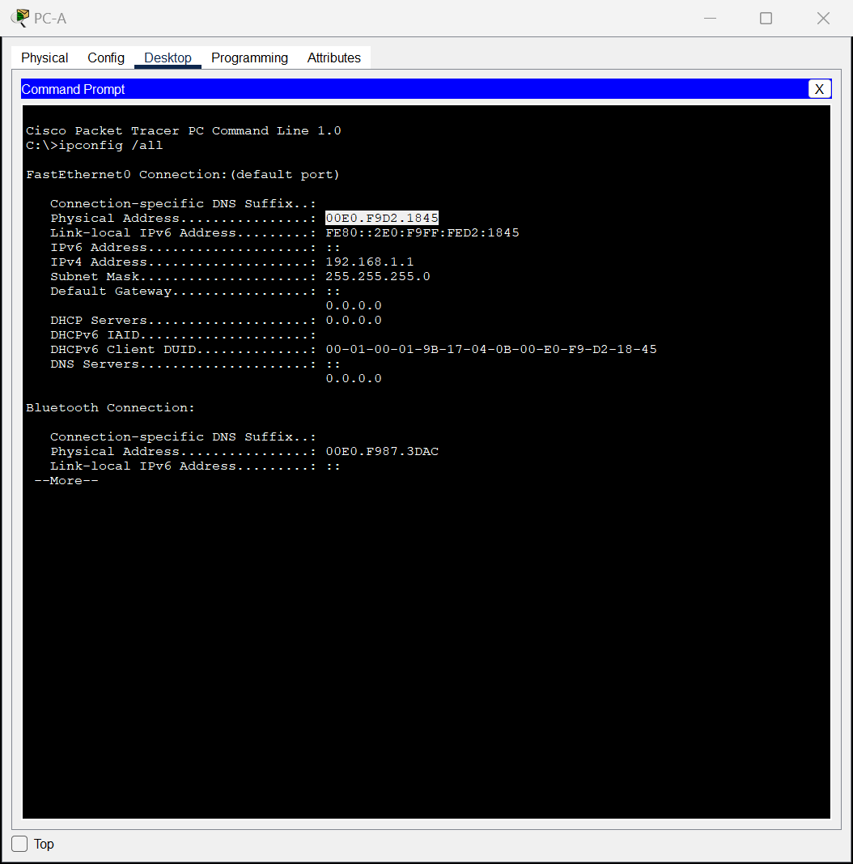

**PC-B MAC Address:** 00D0.FF9D.444D

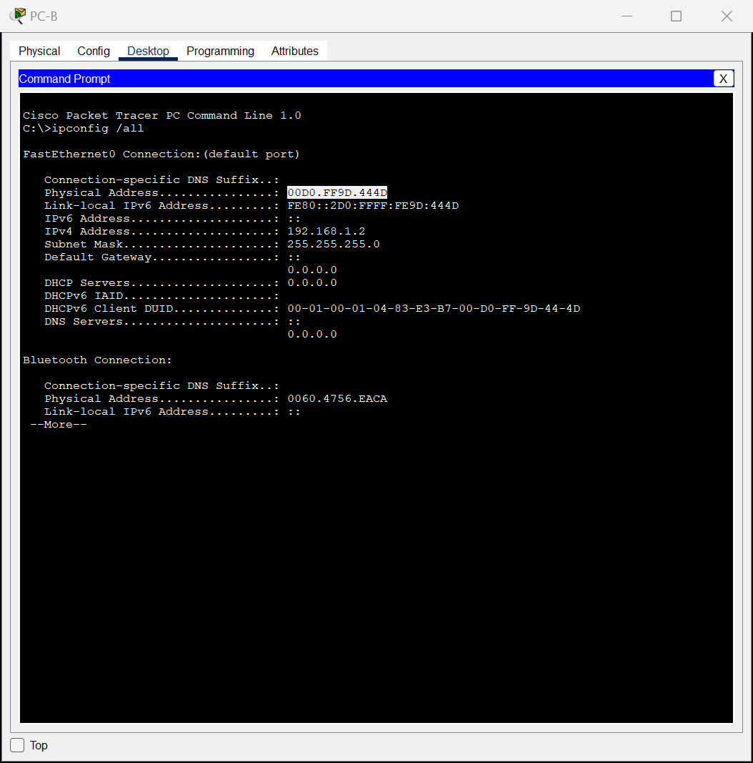

**Ex2/ Part 2**/Step 1/b:

**S1 Fast Ethernet 0/1 MAC Address**: 0002.1732.3301

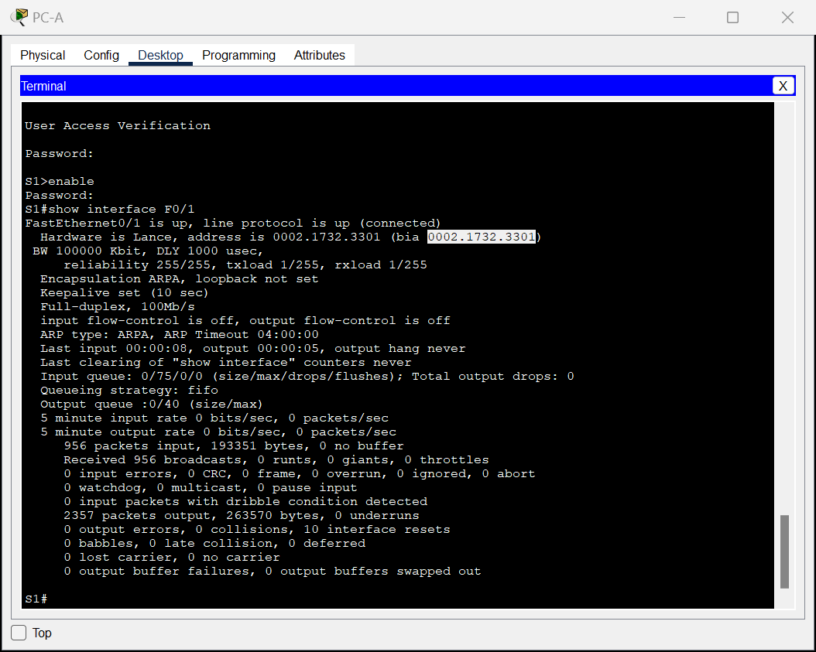

**S2 Fast Ethernet 0/1 MAC Address**: 0001.9651.1e01

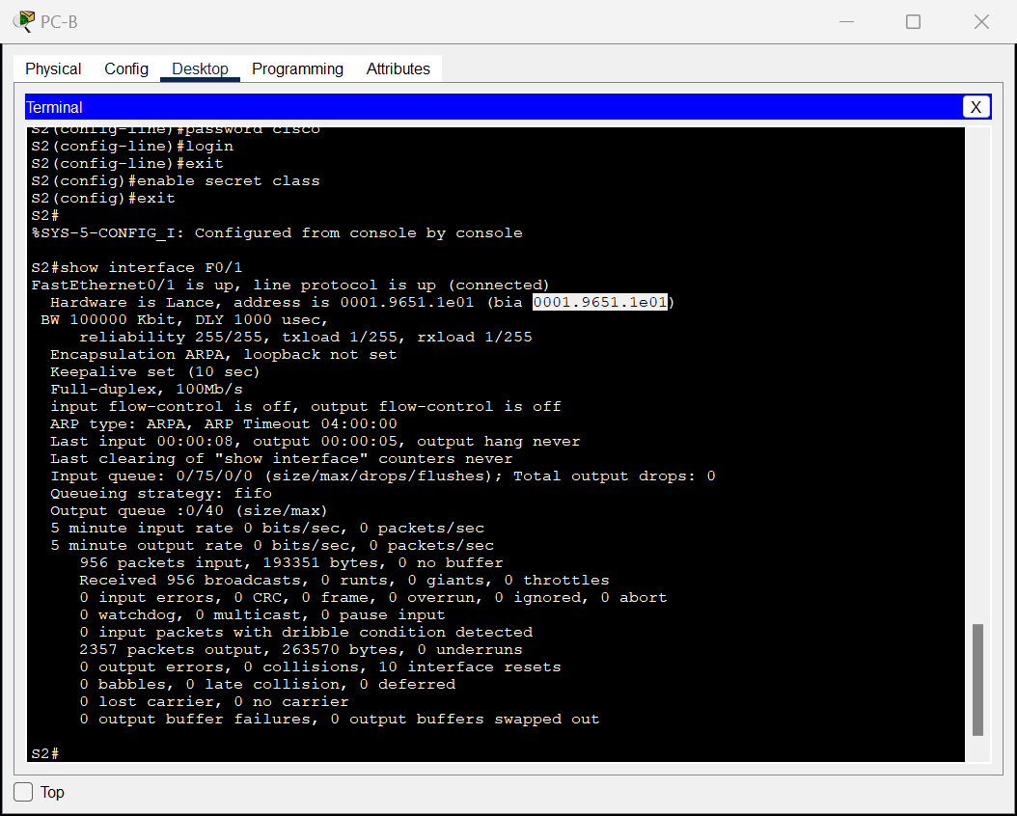

**Ex2/ Part 2**/Step 2/a:

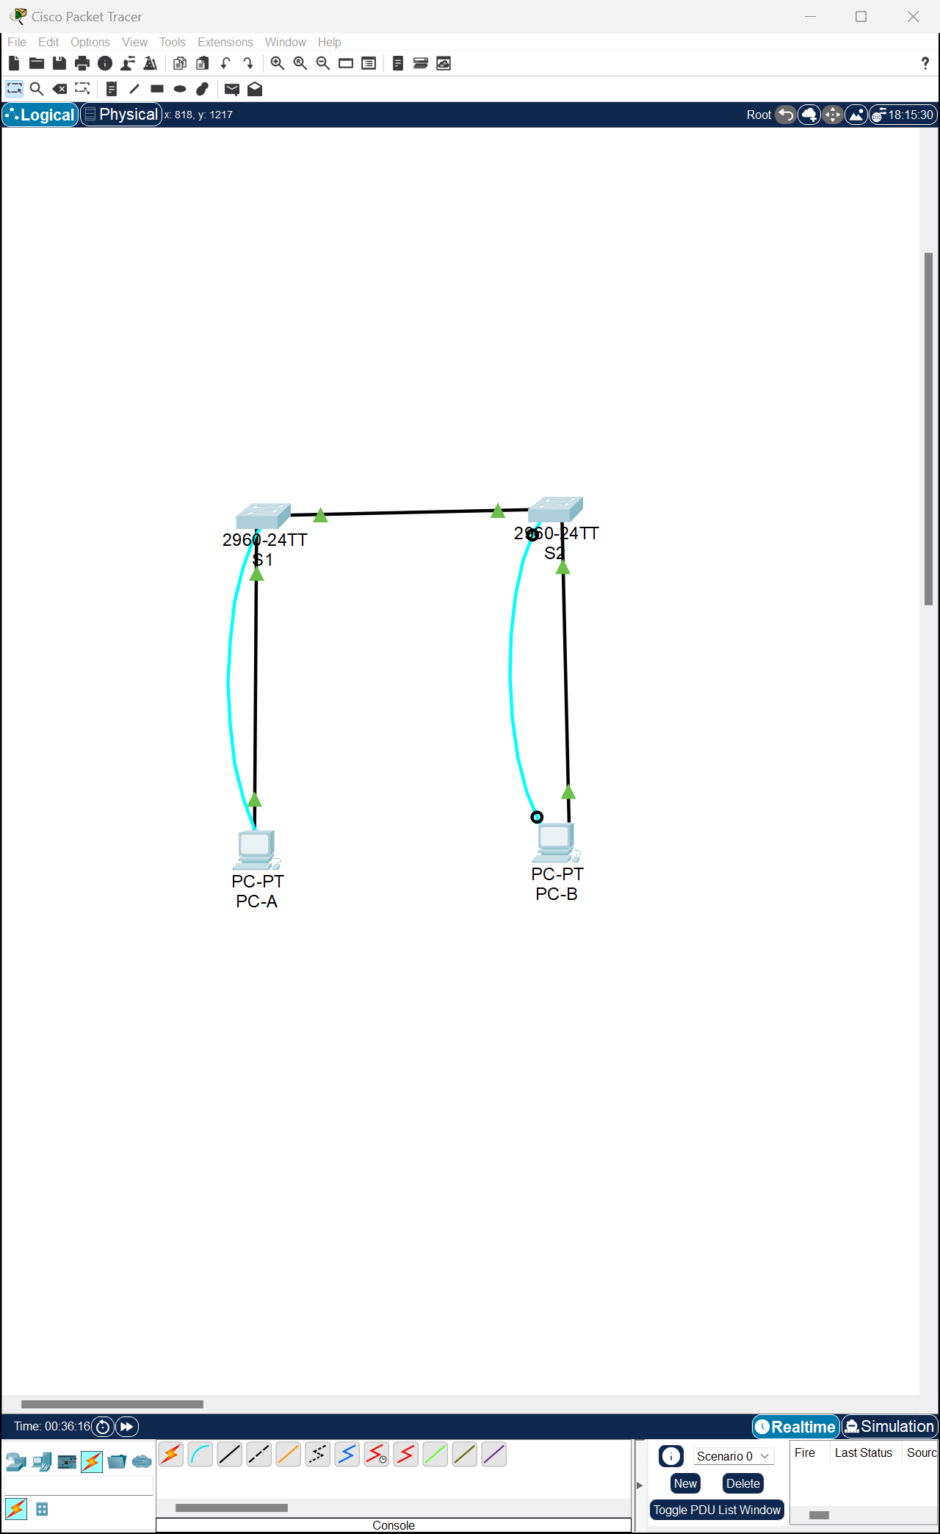

**Ex2/ Part 2**/Step 2/b.

* **Are there any MAC addresses recorded in the MAC address table?**

Yes.

* **What MAC addresses are recorded in the table? To which switch ports are they mapped and to which devices do they belong? Ignore MAC addresses that are mapped to the CPU.**

The S1’s MAC address recorded in via Fa0/1 switch port.

* **If you had not previously recorded MAC addresses of network devices in Step 1, how could you tell which devices the MAC addresses belong to, using only the output from the show mac address-table command? Does it work in all scenarios?”** show mac address-table command” shows the port that the MAC addresses were learned on and it would identify the MAC address belongs to which network device in the simple network system.

But when multiple MAC addresses associated to the same port or the device uses a dynamic address, MAC addresses might not be directly correlated with specific devices.

**Ex2/ Part 2**/Step 3:

a.

b.

* **Does the MAC address table have any addresses in it for VLAN 1? Are there other MAC addresses listed?**

No. Just S1’s MAC address re-recorded in via Fa0/1 switch port.

* **Wait 10 seconds, type the show mac address-table command, and press Enter. Are there new addresses in the MAC address table?**No, the same line showed.

**Ex2/ Part 2**/Step 4/a.

* **Not including multicast or broadcast addresses, how many devices IP-to-MAC address pairs have been learned by ARP?**

ARP cache have no entries in it.

**Ex2/ Part 2**/Step 4/b.

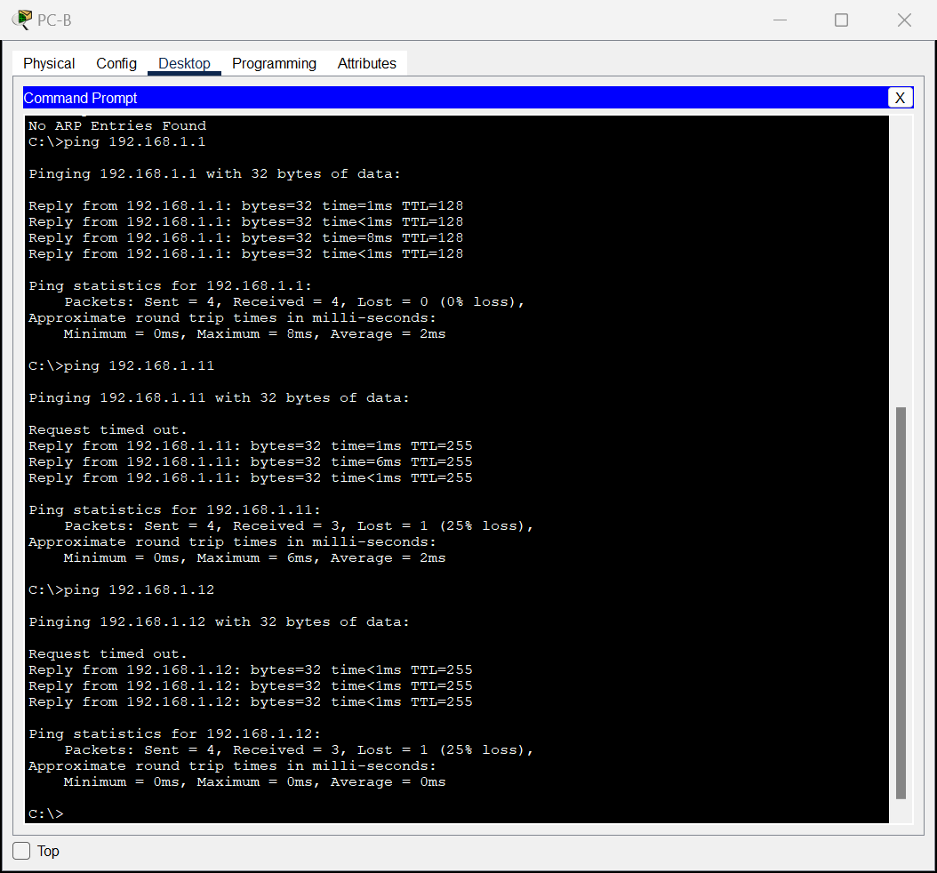

* **Did all devices have successful replies? If not, check your cabling and IP configurations.**

Yes, all devices have successful replies.

**Ex2/ Part 2**/Step 4/c.

* **Has the switch added additional MAC addresses to the MAC address table? If so, which addresses and devices?**

Yes, including S1(1st line), PC-A(4th line) , PC-B(2nd line),

文本

* **Does the PC-B ARP cache have additional entries for all network devices that were sent pings?**

Yes, PC-A(1st line), S1(2nd line), S2(3rd line).

**Ex2/ Part 2**/**Reflection Question:**

what might be some of the challenges on larger networks?

1. **ARP Cache Size Limitations:** on the large network system, the number of entries may surpass the capacity of the caches.
2. **MAC Address Table Scalability:** the number of MAC addresses can handle may limited.
3. **Dynamic Nature of Devices:** Devices on the large network are often dynamic, the displayed data deviates from the real situation.

# Packet Tracer-

# Build a Switch and Router Network - Physical Mode

**Ex3/ Part 1**/a.&b.&c.&d.

**Ex3/ Part 2**/Step1/a.

**Ex3/ Part 2**/Step1/b.

**Ex3/ Part 2**/Step1/c. **Why were the pings not successful?**

Layer 3 traffic isn't being routed between subnets because the router interfaces (default gateways) haven't been configured yet.

**Ex3/ Part 2**/Step2/d.&e.& f.& g.& h.

**Ex3/ Part 2**/Step2/i.&j.&k.&l.

**Ex3/ Part 2**/Step2/m.&n. **Were the pings successful? Explain.**

Yes. The router effectively routes traffic between the two subnets. The default configurations of the 2960 switch automatically activate the interfaces linked to devices.

**Ex3/ Part 2**/Step3/a.&b.&c.& d.& e.&f.

**Ex3/ Part 2**/Step4/a.

**文本

**

**Ex3/ Part 2**/Step4/b.

**Ex3/ Part 3**/Step1/a.

**What code is used in the routing table to indicate a directly connected network?**

C (a directly connected subnet)

L (a local interface)

**How many route entries are coded with a C code in the routing table?**

TWO.

**What interface types are associated to the C coded routes?** G0/0/0 & G0/0/1.

**Ex3/ Part 3**/Step1/b.

**Ex3/ Part 3**/Step2/a.

**What is the operational status of the G0/0/1 interface?**

GigabitEthernet0/0/1 is up, line protocol is up

**What is the Media Access Control (MAC) address of the G0/1 interface?**

0060.4731.8102

**How is the internet address displayed in this command?**

192.168.1.1/24

**Ex3/ Part 3**/Step2/b.

**Ex3/ Part 3**/Step3/a.

**Ex3/ Part 3**/Step3/b.

**Ex3/ Part 3**/Step3/c.

**Ex3/ Part 3**/ Reflection Questions/1. **If the G0/0/1 interface showed that it was administratively down, what interface configuration command would you use to bring the interface up?**

R1(config-if)# no shutdown

**Ex3/ Part 3**/ Reflection Questions/2. **What would happen if you had incorrectly configured interface G0/0/1 on the router with an IP address of 192.168.1.2?**

PC-A cannot ping PC-B as they belong to different networks. To route packets to PC-B, PC-A requires the default gateway router. However, PC-A is configured to use 192.168.1.1 as the default gateway router, which isn't assigned to any device on the LAN. Consequently, packets destined for the default gateway cannot reach their intended destination for routing.

表格

# Packet Tracer - Examine the ARP Table

**Ex4/ Part 1/**Step 1/b:



**Ex4/ Part 1/**Step 1/c:

日历

**Ex4/ Part 1/**Step 1/d: Click Capture/Forward once. The ARP PDU moves Switch1 while the ICMP PDU disappears, waiting for the ARP reply. Open the PDU and record the destination MAC address.

**Is this address listed in the table above?**

No.

**Ex4/ Part 1/**Step 1/e. **Click Capture/Forward to move the PDU to the next device.**

**How many copies of the PDU did Switch1 make?**

3.

**Ex4/ Part 1/**Step 1/f. **What is the IP address of the device that accepted the PDU?**

表格

172.16.31.3

**Ex4/ Part 1/**Step 1/g. Open the PDU and examine Layer 2. **What happened to the source and destination MAC addresses?**

FFFF.FFFF.FFFF turned into MAC address of 172.16.31.3, Source became destination.

**Ex4/ Part 1/**Step 1/ h. Click Capture/Forward until the PDU returns to 172.16.31.2. **How many copies of the PDU did the switch make during the ARP reply?**

One.

**Ex4/ Part 1/**Step 2/a. Note that the ICMP packet reappears. Open the PDU and examine the MAC addresses. **Do the MAC addresses of the source and destination align with their IP addresses?**

Yes.

**Ex4/ Part 1/**Step 2/ b. Switch back to Realtime and the ping completes.**图形用户界面

**

**Ex4/ Part 1/**Step 2/ c. Click 172.16.31.2 and enter the arp –a command. **To what IP address does the MAC address entry correspond?**

172.16.31.3

**Ex4/ Part 1/**Step 2/ d. In general, **when does an end device issue an ARP request?** When the receiver’s MAC address is unknown.

**Ex4/ Part 2/**Step 1/ a. From 172.16.31.2, enter the ping 172.16.31.4 command.

日历

**Ex4/ Part 2/**Step 1/c. Enter the ping 10.10.10.3 command. **How many replies were sent and received?**

4 sent, 4 received.

**Ex4/ Part 2/**Step 2/a. Click Switch1 and then the CLI tab. Enter the show mac-address-table command. **Do the entries correspond to those in the table above?**

Yes.

**Ex4/ Part 2/**Step 2/b. Click Switch0, then the CLI tab. Enter the show mac-address-table command. **Do the entries correspond to those in the table above?**

Yes.

**Ex4/ Part 2/**Step 2/c. **Why are two MAC addresses associated with one port?**

Both devices connect to one port through the Access Point.

**Ex4/ Part 3/**Step 1/a. Click 172.16.31.2 and open the Command Prompt.

**Ex4/ Part 3/**Step 1/b. Enter the ping 10.10.10.1 command.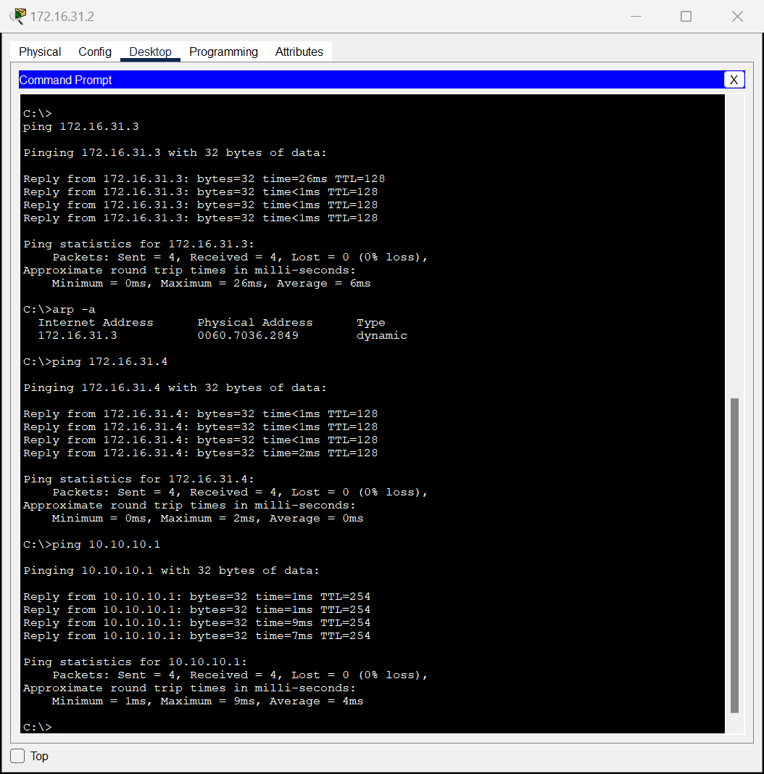

**Ex4/ Part 3/**Step 1/c. Type arp –a. **What is the IP address of the new ARP table entry?**

172.16.31.1

**Ex4/ Part 3/**Step 1/ d. Enter arp -d to clear the ARP table and switch to Simulation mode.



**Ex4/ Part 3/**Step 1/ e. Repeat the ping to 10.10.10.1. **How many PDUs appear?**

Two.

**Ex4/ Part 3/**Step 1/ f. Click Capture/Forward. Click the PDU that is now at Switch1. **What is the target destination IP destination address of the ARP request?**

172.16.31.1

**Ex4/ Part 3/**Step 1/ g. The destination IP address is not 10.10.10.1. **Why?**

The host's IPv4 configuration stores the gateway address, typically the router interface within the same network. If the destination isn't on the local network, the source initiates the ARP process to find the MAC address corresponding to the router interface acting as the gateway.

**Ex4/ Part 3/**Step 2/a. Switch to Realtime mode. Click Router1 and then the CLI tab.

**Ex4/ Part 3/**Step 2/b. Enter privileged EXEC mode and then the show mac-address-table command. **How many MAC addresses are in the table? Why?**

Zero, because the command "show mac address-table" serves a distinct purpose compared to the switch command.

**Ex4/ Part 3/**Step 2/c. Enter the show arp command. **Is there an entry for 172.16.31.2?** **What happens to the first ping in a situation where the router responds to the ARP request?**

Yes. The times out.

